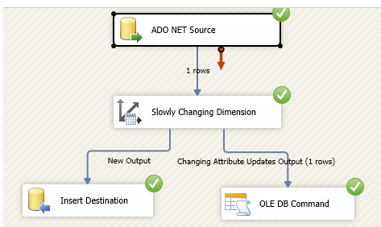

Type 1: update

|  |  |  |
| --- | --- | --- |
| ACTUAL  TABLE: STATE | INPUT  TABLE: STATE_TMP | OUTPUT  TABLE: STATE |
|  |  |  |

Configure SCD control

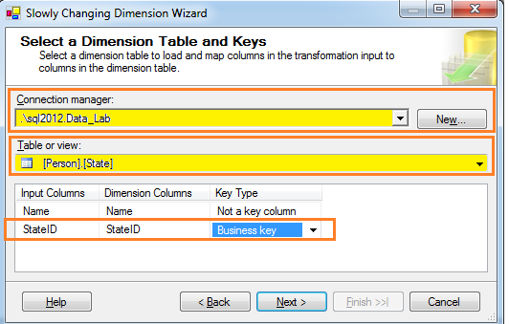

Configure:

* Connection
* Source table**: State**
* Set field **StateID** as Business key

Click next

Now, select the **name** column and choose the SCD type. (columns are StateID and name)

1. Fixed attribute, SCD Type 0, the column will never change
2. Changing attribute, SCD Type 1
3. Historical attribute, SCD Type 2

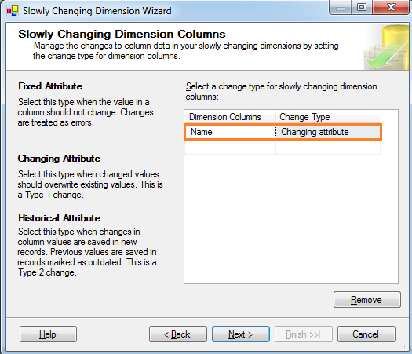

The fields in table State were set:

* StateID was set as Business key (unique)
* Name was set as Changing attribute

Click next

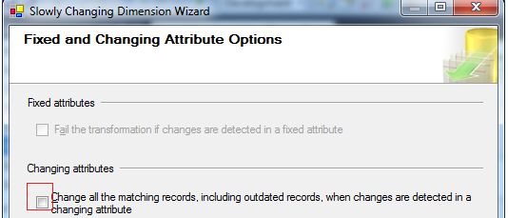

Click next

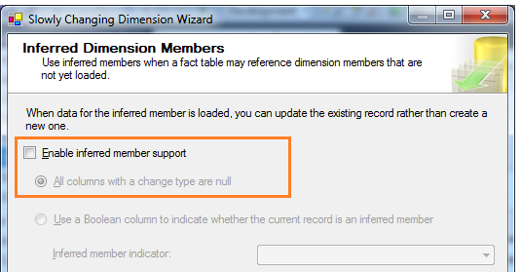

Uncheck the “Enable inferred member support” and click next.

Then click Finish

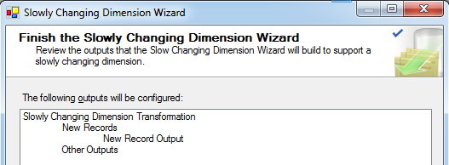

For the output

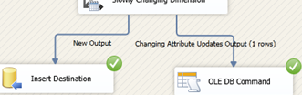

* Set condition for **New Output** and assign to the same source table
* Create an Ole Db Command to make the update

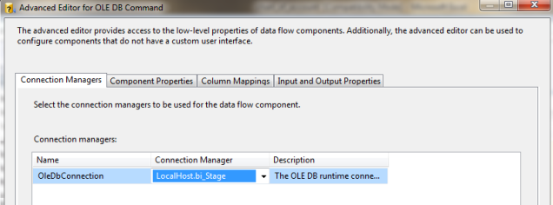

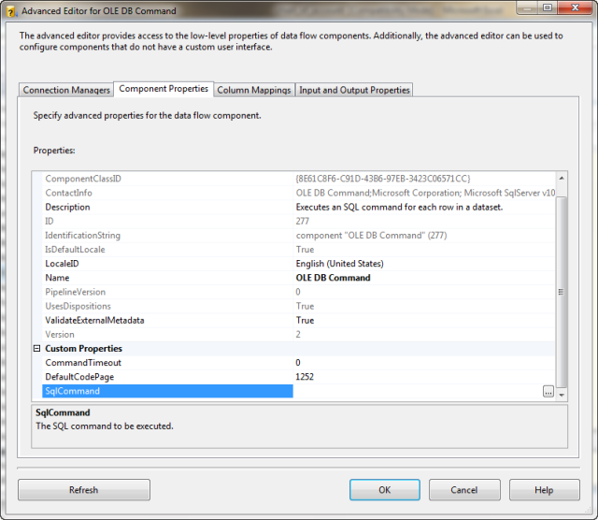

SqlCommand **Update State Set name =? Where StateId = ?**

Then make a Column Mapping to assign the “?” to the right column

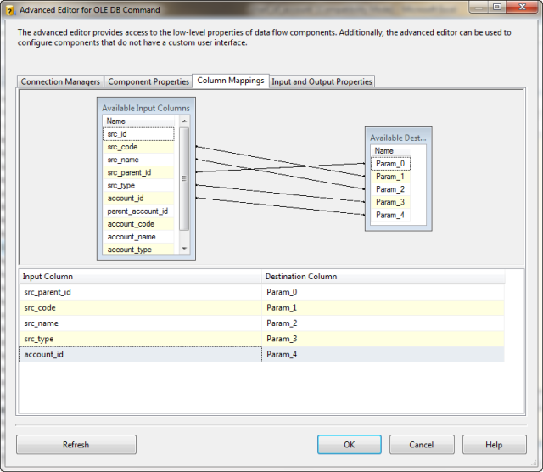

Click OK. Now we are ready to execute the SSIS.